Surge AUTIN – Problem Management Dashboard



Issue | V1.0
Date | 12/08/2026


Huawei Technologies Co., Ltd.
All rights reserved
(For internal use only)

- About This Document
Project Name | Surge MS AUTIN Project
Document Name | Problem Management Dashboard
Involved Module | GDE Dashboard – Problem Ticket Dashboard
Confidentiality Level | Internal
Version | DRAFT V1.0
Requirment Source | Monitoring tool for Problem Tickets (PT), SLA compliance, aging, and partner performance

- Update History

Date | Revised Version | Modified the description. | Author
2026-08-12 | v1.0 | Initial Version | Andera Singgih Pratama

Contents
1. Purpose of the Dashboard 4
2. System Architecture 6
2.1. Front End 6
2.2. Back End(Run Script) 6
2.3. Party Configuration Storage 7
3. Dashboard Layout Overview 8
4. Header Area & Filter 9
5. Top Summary Cards 10
6. Partner Breakdown Cards 10
7. Section 1 — Severity Overview (SLA Based) 10
8. Section 2 — Phase Status by Responsibility Party 11
9. Section 3 — Weekly Trend 12
10. Section 4 — Top Root Cause 13
11. Section 5 — Edging PT vs SLA Compliance 14
12. Section 6 — SLA Pause Reason 14
13. Section 7 — Problem Ticket List 15
14. Party Configuration Page 15
15. Field Reference Summary 16
16. Key Business Rules 17
17. Auto Refresh 18

Purpose of the Dashboard
The Problem Management Dashboard is a monitoring page within the OWS GDE Portal used to track Problem Tickets (PT) — network issues that have gone through the formal ticketing process. It provides Operations and Management with visibility into:
- Ticket volume by status (Open, Pending, Closed, Canceled, Paused)
- Ticket distribution by partner/vendor
- Severity distribution and SLA compliance
- Current phase and aging per ticket
- Root cause distribution
- Weekly trend of new, implemented, closed, and pending tickets
- Detailed, searchable ticket-level data
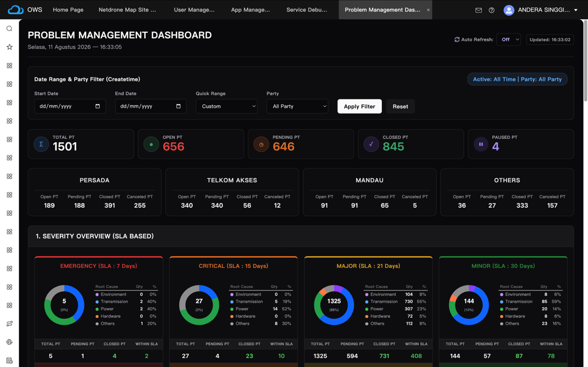

System Architecture

Front End
The dashboard is implemented as a custom widget embedded within the OWS GDE Portal, built using three standard OWS GDE Studio components on the same page:
- HTML Panel defines the static layout structure and placeholder containers (filter section, stat card containers, chart containers, table containers). Most containers are empty by default and populated dynamically at runtime.
- JavaScript (Script) the primary logic layer. It retrieves data from the backend service, normalizes raw ticket fields, performs all aggregation and calculation, renders results into the HTML Panel containers, and handles user interaction (filtering, search, sorting, pagination, tab switching, modals).
- CSS (Style) defines visual styling for all dynamically generated elements (cards, tables, badges, buttons, modal, tags), since these are not covered by default OWS component styling.
All aggregation and grouping logic is performed within the script, after the full dataset has been retrieved the backend service only returns matching ticket records; the frontend performs calculation and rendering.

Back End(Run Script)
A server-side RunScript executes on the OWS platform, constructing a TQL query based on the provided filter parameters and returning matching Problem Ticket records.
Target Data Model: /ProblemTicket/ProblemTicket/pt_problemticket
Service ID: /adc-service/rest/v1/services/gde_dashboard/problem_ticket_dashboard/problem_ticket_getsummarysc
Request parameters:
Parameter | Description
startDate / endDate | Date range filter, applied against the model's createtime field
party | Partner filter registered partner name, raw ID/UUID, or ALL
start / limit | Pagination offset and page size (capped at 1000 per request server-side)

Because each request is capped at 1000 rows, the frontend performs sequential pagination repeatedly requesting the next batch until the retrieved row count matches the server-reported total before rendering.

Party Configuration Storage
Data Model: /ProblemTicket/ProblemTicket/problem_ticket_dashboard_party_config
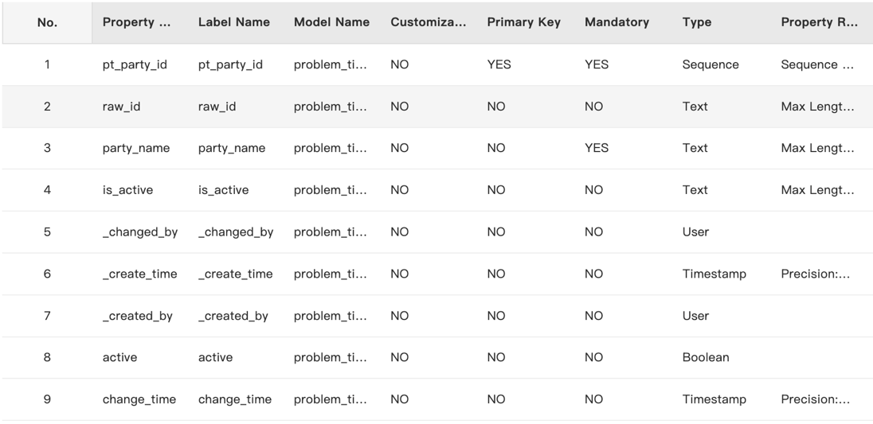
Accessed through REST services under gde_dashboard/problem_ticket_dashboard:
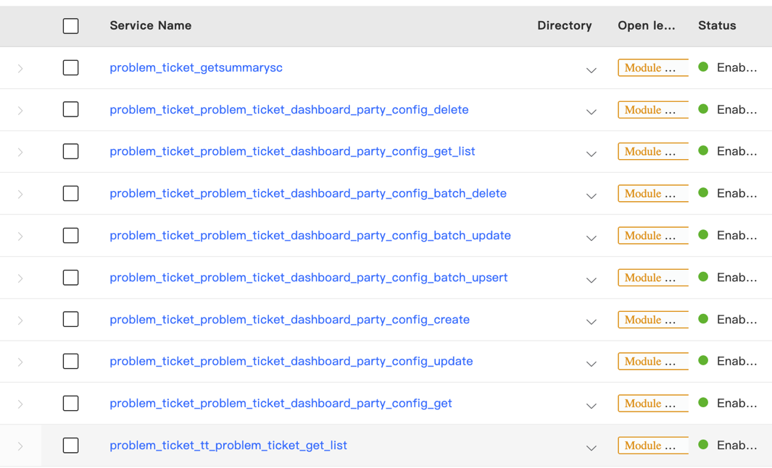

Dashboard Layout Overview
  - Date Range & Party Filter
  - Top Summary Cards
  - Partner Breakdown Cards
  - Section 1 – Severity Overview
  - Section 2 – Phase Status by Responsibility Party
  - Section 3 – Weekly Trend
  - Section 4 – Top Root Cause
  - Section 5 – SLA Compliance
  - Section 6 – SLA Pause Reason
  - Section 7 – Problem Ticket List
A separate Party Configuration page manages the registered partner list (Section 15).

Header Area & Filter
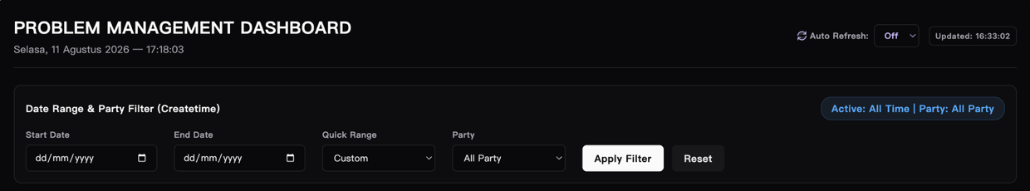
Filter panel: "Date Range & Party Filter (Createtime)" — filters against the ticket's createtime field.
- Start Date / End Date — must be provided together; validated so Start Date ≤ End Date. Internally converted to start_time (00:00:00) / end_time (23:59:59) before being sent to the backend.
- Quick Range — Today, Current Week, Last 1 Week, Last 2 Weeks, based on a Thursday–Wednesday week cycle.
- Party — filters against the responsibility field (resolved via Party Configuration mapping), or ALL, or Others.
- Apply Filter / Reset.
- "Active: ..." badge showing the currently applied filter.
When a Party filter is active, a badge is appended to each section header further down the page.

Top Summary Cards
Card | Source Fields | Definition
Total PT | ticketstatus | ticketstatus NOT IN ('cancel')
Open PT | ticketstatus | ticketstatus = ‘running’
Pending PT | current_phase, ticketstatus | (current_phase = 'Implement PT' OR current_phase = 'Confirm PT') AND ticketstatus NOT IN ('completed', 'cancel')
Closed PT | ticketstatus | ticketstatus ('completed') AND closetime IS NOT NULL
Paused PT | slapausing | slapausing = ‘YES’

Partner Breakdown Cards
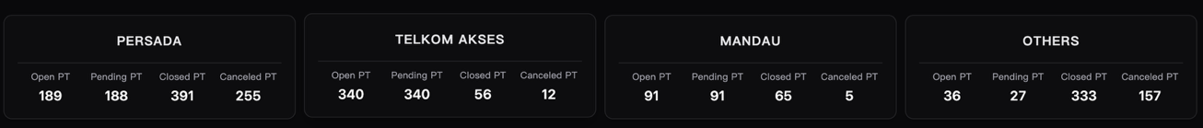
One card per registered partner (from party_name in the Party Configuration model), plus a fixed Others card. Each card shows Open PT, Pending PT, Closed PT, Canceled PT for that partner.
Partner resolution is based on the ticket's responsibility field (source field name: problem_responsible_party), matched in order against: (1) raw_id → party_name mapping, (2) partial match against mapped raw_id values, (3) partial match against registered party_name values. No match → Others.

Section 1 — Severity Overview (SLA Based)
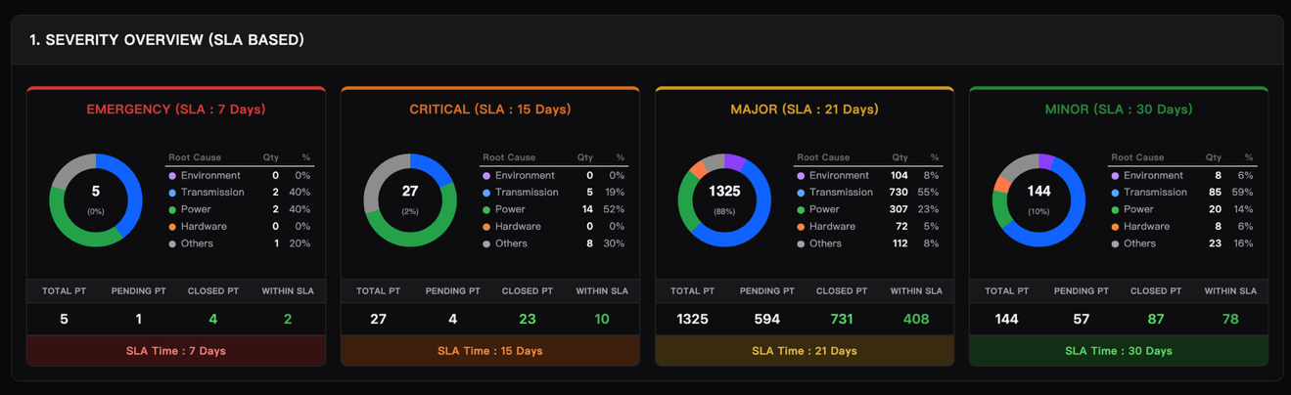
Source field: createticketlevel
Severity | SLA Target
Emergency | 7 Days
Critical | 15 Days
Major | 21 Days
Minor | 30 Days
Root cause breakdown per severity uses the root_cause field. Summary row uses ticketstatus (for Pending/Closed) and the derived over_sla flag (for Within SLA). Canceled tickets (ticketstatus) are excluded. Unrecognized severity/createticketlevel values default to Minor.

Section 2 — Phase Status by Responsibility Party
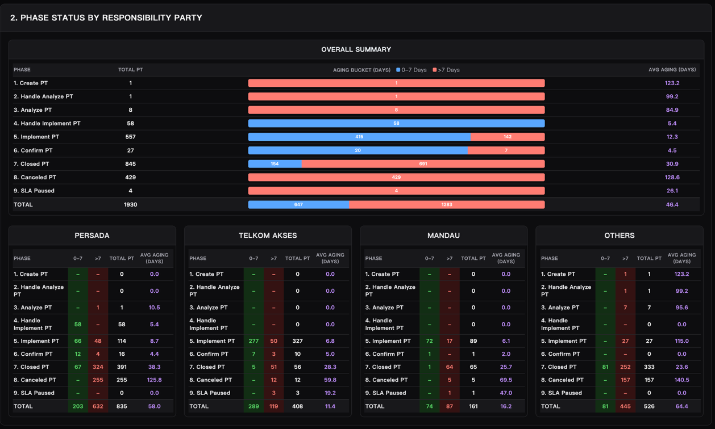
Source fields: slapausing (SLA Paused check), ticketstatus (Closed/Canceled check), current_phase/operate_phase (remaining phase text match).
Phase list: Create PT, Handle Analyze PT, Analyze PT, Handle Implement PT, Implement PT, Confirm PT, Closed PT, Canceled PT, SLA Paused.
Aging is phase-relative, calculated from checkpoint timestamp fields depending on current phase:
Current Phase | Start Time Field Used (Priority Order)
Handle Analyze PT | tt10_submittime → tt11_createtime → createtime
Analyze PT | tt11_submittime → tt12_createtime → tt10_submittime → createtime
Handle Implement PT | tt12_submittime → pt10_createtime → tt11_submittime → createtime
Implement PT | pt10_submittime → pt12_createtime → tt12_submittime → createtime
Confirm PT | pt12_submittime → pt14_createtime → pt10_submittime → createtime
Closed/Canceled | createtime → closetime
tt10–tt12 fields correspond to Trouble Ticket stage checkpoints; pt10–pt14 fields correspond to Problem Ticket stage checkpoints, both from the source ticketing system.
Each row is split into two aging buckets (0–7 days, >7 days) with an Average Aging (Days) figure.

Section 3 — Weekly Trend
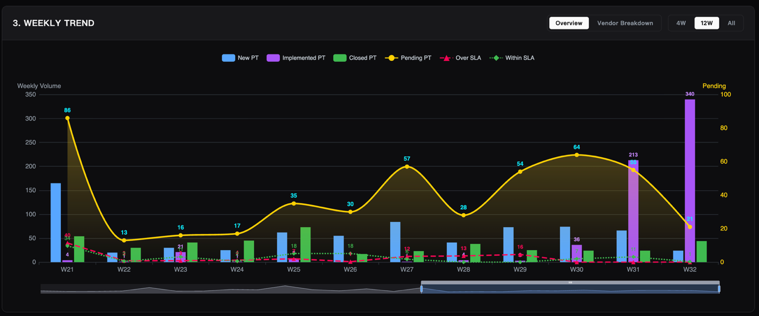
Week grouping is derived from createtime (Thursday–Wednesday cycle, Week 1 fixed to Jan 1st).
Series | Source Fields | Condition | Group By Field
New PT | createtime | createtime IS NOT NULL  GROUP BY WEEK(createtime) | Createtime(Week)
Implemented PT | current_phase,pt12_submittime | current_phase = 'Implement PT' AND pt12_submittime IS NOT NULL | pt12_submittime(Week)
Closed PT | ticketstatus, closetime | ticketstatus = 'completed' AND closetime IS NOT NULL | closetime(Week)
Pending PT | ticketstatus, current_phase, createtime | ticketstatus NOT IN ('completed', 'cancel') AND (current_phase = 'Implement PT' OR current_phase = 'Confirm PT') | createtime(Week)
Over SLA | ticketstatus, slastatus, createtime | ticketstatus = 'completed' AND slastatus = 'sla_violation' | createtime(Week)
Within SLA | ticketstatus, slastatus, createtime | ticketstatus = 'completed' AND slastatus = 'normal' | Createtime(Week)
View modes: Overview / Vendor Breakdown (Pending PT split by responsibility-resolved partner). Timeframe controls (4W/12W/All) adjust the visible chart window only.

Section 4 — Top Root Cause
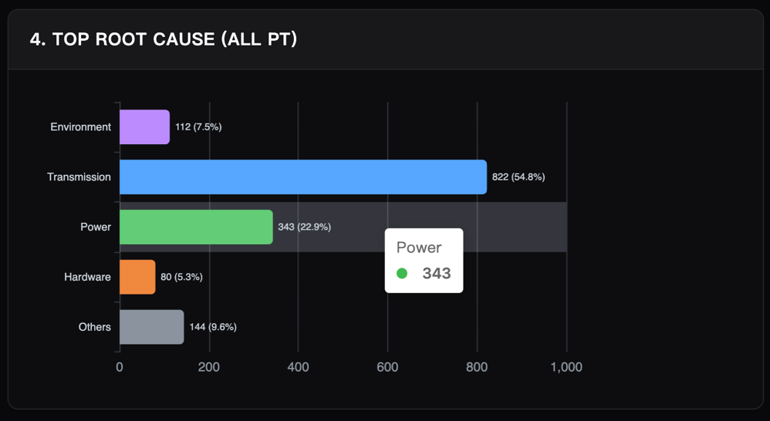
Source field: root_cause
Categorized into Environment, Transmission, Power, Hardware, or Others based on keyword matching against root_cause. Non-canceled tickets only (ticketstatus).
Clicking a bar opens the Sub Root Cause breakdown, sourced subrootcause
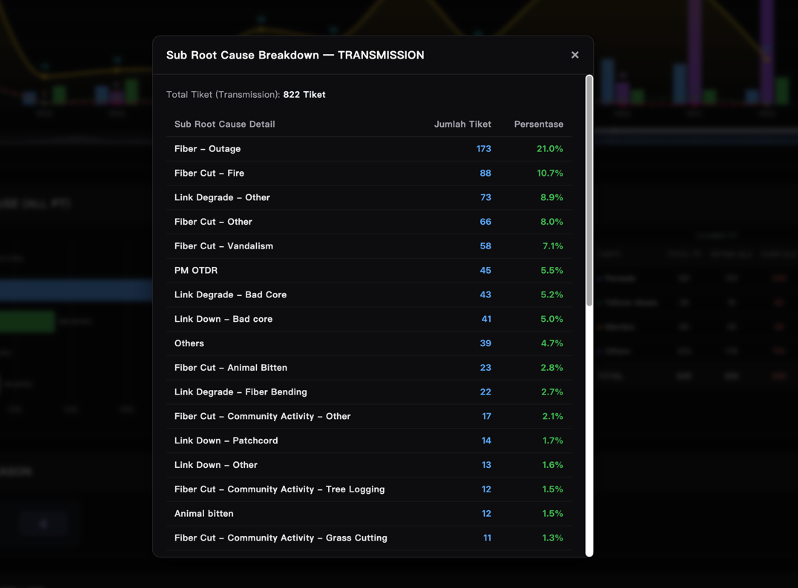

Section 5 — Edging PT vs SLA Compliance
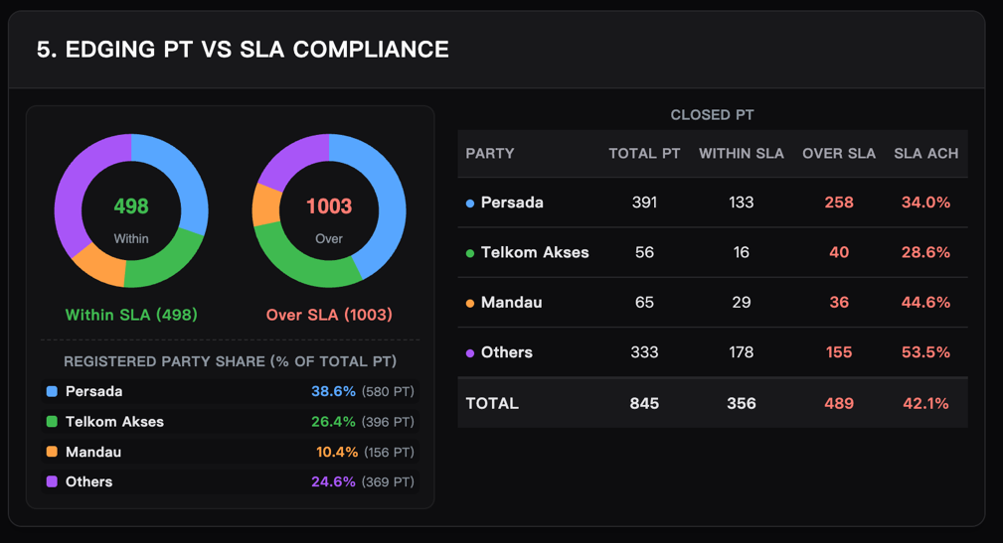
Donut charts: all non-canceled tickets (ticketstatus), classified via the derived slastatus = sla_violation.
Closed PT table: only tickets where ticketstatus = Completed. Columns: Total PT, Within SLA, Over SLA (both from slastatus = sla_violation), and SLA Achievement % (Within SLA ÷ Total PT).

Section 6 — SLA Pause Reason
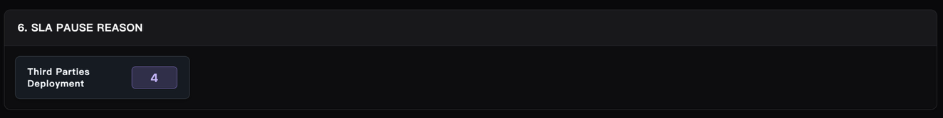
Source fields: slapausing (filter: Yes/True/1), slapausereason
Raw reason values (typically PascalCase, e.g. SLAPauseReasonThirdPartiesDeployment) are cleaned by stripping the SLAPauseReason prefix and inserting spaces before capital letters (e.g., "Third Parties Deployment").

Section 7 — Problem Ticket List
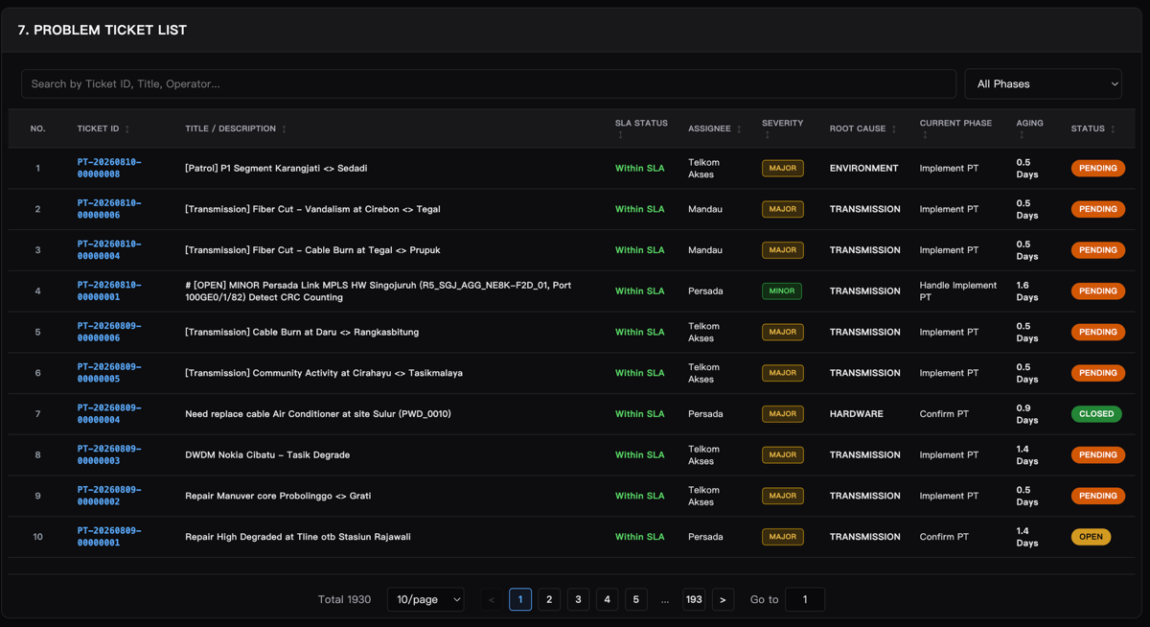
Column | Source Fields
Ticket ID | orderid
Title | title
SLA Status | slastatus, over_sla
Assigne | responsibility
Severity | createticketlevel
Root Cause | root_cause
Current Phase | current_phase
Aging | phase-relative calculation (Section 9)
Status | ticketstatus
Search matches against all fields on the ticket object. Row click opens a detail modal sourced from: title, createptproblemdes (description), createtime, lastupdatetime, closetime, current_phase, createptassignto, currentoperator, lastoperator, originator.
Pagination: page sizes 10/20/50/100, next/previous, direct page entry.

Party Configuration Page
Management interface for problem_ticket_dashboard_party_config (Section 2.3).
- Registered Parties list — active party_name records shown as removable tags.
- Add New Official Party — creates a new party_name record (no raw_id).
- Scan Database / Auto-Detect — scans responsibility values present in the loaded ticket dataset, flags each as Registered or Discovered (Others). Registering a discovered UUID-format value prompts for a display name and creates a raw_id → party_name mapping.

Field Reference Summary
Quick reference of source fields from the pt_problemticket model used throughout the dashboard:
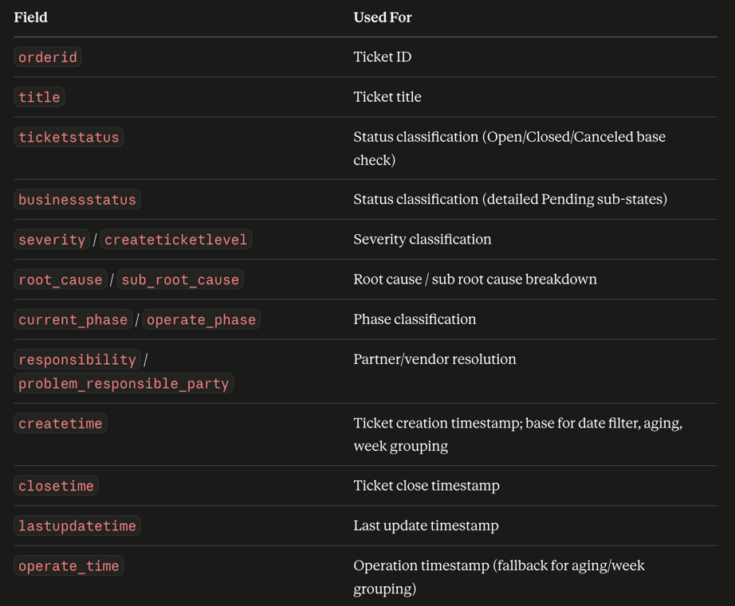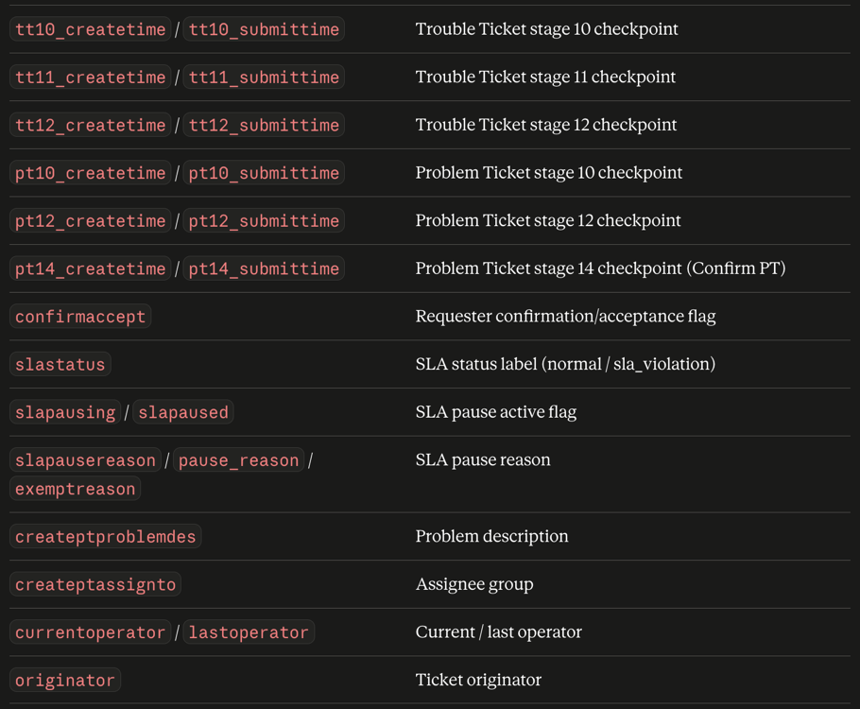

Key Business Rules
"Closed" is defined differently across sections. Most sections use ticketstatus = Closed/Completed. The Weekly Trend section additionally requires confirmaccept = Accept/Yes.
Aging is calculated differently depending on context. Default aging/SLA breach uses createtime. Phase Status and the ticket list's Aging column use phase-relative checkpoints (Section 9 table).
"Pending" in the Weekly Trend is a live snapshot based on current ticketstatus, grouped by createtime week — not a historical pending count.
Weeks run Thursday–Wednesday, Week 1 fixed to createtime's year, January 1st.
Partner assignment is fully automated from responsibility, matched against the Party Configuration model.
SLA targets are severity-based only (from severity/createticketlevel): Emergency 7 days, Critical 15 days, Major 21 days, Minor 30 days.

Auto Refresh
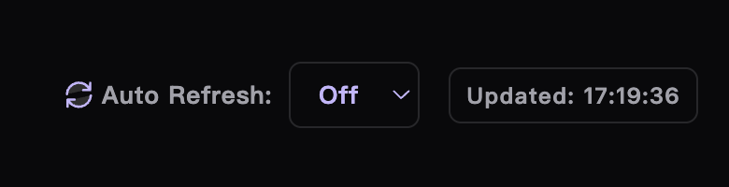
Options: Off / 30s / 1m / 5m. Re-fetches using the currently active filter at the selected interval.

